UNIT 1: Understanding Place Value EXAM ON SEPT.27 & 28, 2018
Engagement (Sept. 4-7): 5.NBT. A1/2 : Multi-digit decimals and powers of 10
How does the position of a digit in a number affect its value? When would you use this in real life?

Group question (Explore): Work in your teams, each team writes in their journal and recorder writes in Table Journal
Day 1: 5678
What happens when there is another place value added to the whole number:
To the left of 5? To the right of 8? Explain and give an example.
Day 2: How many times greater is the 6 in 67,341 than the 6 in 29,046?
Day 3: How many times greater is the value of 8 in 23.085 than the value of the digit 8 in 23.098?
Day 4: Is this equation true? (Show your work!!) 1946.8 ÷n=1.9468 when n=10²
Day 5: Write a 10 digit number that has a 4 in the millions place, a 6 in the hundreds place, and a 7 in the hundredths place. Write out your place value chart and label it.
Friday: Exit Slip (Assessment)
How many times greater is the value of the digit 7 in 56.709 than value of the digit 7 in 56.007
Show your work
A. 1/10
B. 1/100
C. 1/1000
D. 1000 times

Engagement (September 17-21): 5.NBT A2/B7/A4
How does the value of a number change when the decimal point is moved? Why is this important to know for real life?
Group question (Explore): Work in your teams, each team writes in their journal and recorder writes in Table Journal
Day 1: Simon is 12.67 inches tall. His friend Carter is 3.48 inches taller than he is. How much taller is Carter than Simon. What operation did you use and why?
Day 2: Shari and five of her friends went to Applebees for dinner. What is the standard number?
Kris:(2x10)+(2x1)+(9x1/10)+(5x1/100)
Carter: (1x10)+(6x1)+(6x1/10)+(3x1/100)
Thor: (2x10)+(4x1/10)+(7x1/100)
Shari: (1x10)+(9x1)+(2x1/10)+(9x1/100)
Laura: (1x1)+(4x1)+(8x1/10)+(8x1/100)
Day 3: (Using above information) Shari wanted to pay for everyone and wants to know if $100.00 will cover the bill? (Without tip, Kris said she’d leave the waitress $20.00)
Day 4: Round to the nearest ones place. What is the best estimate for 58.35 – 31.92? Round first than subtract and give the estimated answer. Then give the actual answer.
Day 5: Which of these answers is true and which are false? 467.43>467.430, 37.56<37.65, .6=0.60, 1/100=0.01
Friday Exit Slip: Which comparisons are true?
Bugs | Length in inches
Cricket | 0.987
Lady Bug | 0.067
Mosquito | 0.009
Bumble Bee | 1.101
Rhino beetle | 2.371
Cricket>Lady Bug
Rhino beetle<Bumble Bee
Mosquito<Lady Bug
Bumble Bee>Cricket
Mosquito=Lady Bug
Engagement (Sept 24-28, 2018) : NBT
How does the position of a digit in a number affect its value?
Group question (Explore): Work in your teams, each team writes in their journal and recorder writes in Table Journal
Day 1: Write six hundredths as a base ten numeral. Write six tenths as a base ten numeral. Compare the numbers as an inequality equation (use <,>,=)
Day 2/3: Thor (a little fat pug) decided to take a math class. He used 60 ten thousands in the expanded form of the number 5,608,503. Show or explain how 5 hundred thousands, 60 ten thousands, 8 thousands, 5 hundreds, and three ones can or cannot be used to represent 5,608,503. If it cannot be used, show how to correct it and still use 60 ten thousands.

Wednesday Exit Slip: What is the volume?


HOMEWORK SEPT. 5, 2018 (Place in the column to add correctly: show all work)
2,317 + 955 + 3,187 | 1,996 + 6,083 + 1,322
6,978 + 220 + 52 | 1,908 + 5, 098 + 5, 109
26 + 553 + 4,435 | 5,096 + 565 + 9, 145
HOMEWORK SEPT. 6, 2018 (Place in the column to subtract correctly: show all work)
6,397 – 2,976 | 3,880-2,926
5,767 – 158 | 9,403 – 5,133
7,676 – 5,858 | 8,074 – 4,508

HOMEWORK SEPT. 7, 2018
Math is an important part of life. Write a paragraph and give examples about WHY it is important to learn math and use it CORRECTLY. (You may want to give examples of correct and incorrect answer to equations, and what would happen in real life if someone didn’t learn how to do math and someone who did.) Remember to use capital letters, punctuation, subjects, and verbs. Do not use fragments! Check your spelling too! Ask an adult or older sibling to read your answer and see if it makes sense.
______________________________________________________________________________________________________________________________________________________________________________________________________________________________________________________________________________________________________________________________________________________________________________________________________________________________________________________________________________________________________________________________________________________________________________________________________________________________________________________________________________________________________________________________
______________________________________________________________________________________________________________________________________________________________________________________________________________________________________________________________________________________________________________________________________________________________________________________________________

HOMEWORK MONDAY SEPTEMBER, 10, 2018 NBT.A.1

How many times greater is the value of the 9 in 987,712 than the value of the 9 in 398, 721? Show your work by making a chart of the place values. Then EXPLAIN your strategy that you used to solve this problem. Use math vocabulary: place value, times, value, greater, less than. The explanation should be at least a paragraph (6-8 sentences or more) with correct grammar.

Write the standard form: 5 x 100,000)+ (7 x 1,000) + (7 x 10) + (5 x 1) + (2 x 1/10) + (6 x 1/100)

HOMEWORK SEPT 11, 2018 NBT. A.2

GREEN, RED, BLUE
In which of the following equations does n=10²?
- 1721.6 ÷ n= 1.7216
- 72.3 ÷ n= 0.723
- 33.92 ÷ n= 0.03392
- 8.49 ÷ n= 0.849
EXPLAIN your strategy that you used to solve this problem. Use math vocabulary: place value, divide, value, greater, less than, equals. The explanation should be at least a paragraph (6-8 sentences or more) with correct grammar.

RED, BLUE: Thor and Carter are little dogs. They really want to learn math so they can get their pilot’s license (even though they have no thumbs!) Thor said that 3421.9 ÷ n= 34.219 when n=10². Is Thor correct? Show your equation that you used.

BLUE: Carter wants to learn how to move the decimal to find the answers quickly. Can you show Carter how to complete this problem correctly? 67.9296 ÷ n= ? when n= 10³
HOMEWORK SEPTEMBER 12, 2018 NBT.A2/3
GREEN, RED, BLUE
Simon insisted he didn’t need glasses. (Since Simon is a CAT, who has ever heard of cats wearing glasses anyway??) Thor said Simon definitely needs glasses! Carter got out a chart so Simon could take an eye test. Help Simon by indicating if the number follows the rule. The number has a 3 in the ten thousands place, 5 in the tens place, and a 2 in the tenths place.
Yes No
- 14,637,159.28
- 41,839,650.02
- 36,928,731.50
- 10,436,859.27
- 98,736,405.21
EXPLAIN your strategy that you used to solve this problem. Use math vocabulary: place value, place, value, ten thousands, tens, tenths, decimal place. The explanation should be at least a paragraph (6-8 sentences or more) with correct grammar.

RED, BLUE: Choose one number from A,B,C,D, or E (above). Change the digit in the hundred thousands to a zero. Now, write this number in standard form, expanded form, and word form.

BLUE: Take the above standard number. Change another digit to a zero. Write the new number in standard form, expanded form, and word form. Put in an inequality (<,>,=) compared to the above number.

HOMEWORK SEPT. 13, 2018
GREEN, RED, BLUE
Thor insisted he was taller than Carter. Carter exclaimed Thor was WRONG! Thor got mad and started screaming at Carter. Spittle starts flying. Simon steps in to mediate. Simon measured both dogs. Thor is 12.092 inches tall, Carter is 1.99 inches taller. How tall is Carter? Put in an inequality (<,>,=)
EXPLAIN your strategy that you used to solve this problem. Use math vocabulary: place value, greater, less than, decimal point, subtraction and/or addition. The explanation should be at least a paragraph (6-8 sentences or more) with correct grammar.

RED,BLUE: Thor was MAD! So he went online and ordered a pair of Vans platforms. The platform shoe added 1.0237 inches. How tall is Thor with his shoes on? How much taller is Carter now?

BLUE: Carter thought it is funny that Thor is so mad that he’s short. So Carter started walking on his tippy toes (claws). That added 0.321 inches to his height. How much taller is Carter now when Thor has his platform shoes off and then with his shoes on?

HOMEWORK FRIDAY SEPTEMBER 14, 2018
GREEN, RED, BLUE (DO ALL PARTS)
Carter wanted to test his math skills. He was going to apply to work at NASA. Help Carter practice by solving this problem. He used 40 ten thousands in the expanded form of the number 6,407, 590. Help Carter by solving this problem.
- Show or explain how to 6 hundred thousands, 40 ten thousands, 7 thousands, 5 hundreds, and 9 tens can or cannot be used to represent 6,407,590.
- If it cannot be used, show how you would correct it and still use 40 ten thousands.
Show and explain your work below:
HOMEWORK MONDAY SEPT. 17, 2018
GREEN, RED, BLUE
Simon is the math whiz of the bunch. He taught Thor and Carter about rounding. He gave them a problem to solve. Round to the nearest ones place. What’s the best estimate for 50.44 – 23.67 and why?
EXPLAIN your strategy that you used to solve this problem. Use math vocabulary: place value, estimate, value, rounding. The explanation should be at least a paragraph (6-8 sentences or more) with correct grammar.

RED, BLUE
Carter said it doesn’t make any difference if it’s rounded to the ones place or the tenths. Thor said he was wrong. Help solve this problem. Who’s right and who’s wrong. Round the above number to the nearest tenth and solve.

BLUE
Add a digit to the thousandths place to the above numbers. Round to the nearest hundredths and then subtract.

HOMEWORK TUESDAY SEPTEMBER 18, 2018
GREEN, RED, BLUE
Thor and Carter like science and want to look at bugs. (Thor likes to hit them in the head, true statement.) They caught 5 bugs, measured them in centimeters. Which comparisons are true? (Write out the numbers for each bug then determine if the comparisons are true or false.)
BUG | LENGTH (cm)
Stick Bugs | 3.597
Praying Mantis | 7.182
Stink Bugs | 0.718
Pumpkin Beetle | 0.432
Ant | 0.182
T F
Ant > Pumpkin Beetle
Praying Mantis > Stick Bugs
Ant > Stink bugs
Pumpkin Beetle > Stink Bugs
Stink bugs < Praying Mantis
EXPLAIN your strategy that you used to solve this problem. Use math vocabulary: place value, inequality, greater than, less than, equal, compare. The explanation should be at least a paragraph (6-8 sentences or more) with correct grammar. (Write on the back if you need to)

RED, BLUE: Thor wanted to know how much bigger a Stink Bug is than a Pumpkin Beetle. Help him by solving this problem.

BLUE: Make up your own chart like in Part A. Give 2 Trues and 2 Falses.
HOMEWORK WEDNESDAY SEPTEMBER 19, 2018
GREEN, RED, BLUE
Thor, Carter, and Simon decided they would build a clubhouse. Since Simon is the math whiz, he takes charge as the engineer. He makes a design like a cube.
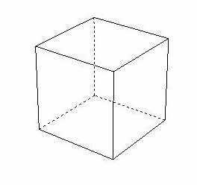 one unit cube
This Photo by Unknown Author is licensed under CC BY-SA
The cube is made of 216 smaller cubes. What is the total volume of the cubes? EXPLAIN your strategy that you used to solve this problem. Use math vocabulary: volume, units, cubes, cubic units. The explanation should be at least a paragraph (6-8 sentences or more) with correct grammar.

RED, BLUE: The formula for volume is l x w x h. Simon proposes a second design. Solve this problem and what type of 3-D figure is it? (cube, sphere, rectangular prism)

BLUE: Put the cube volume formula in a table. Put in a table for example:
1 x 1 x 1= 1 cu³
2 x 2 x 2= 8 cu³
Continuing this pattern, can you figure out the formula for the first volume of the cube of 216 cu³?
HOMEWORK THURSDAY SEPTEMBER 20, 2018
GREEN, RED, BLUE
Carter was SUPER excited about this plan. Simon had built a model and left it on the floor when he left to get a snack. Carter started running around and knocked off two levels. He shoved the blocks under the bed and pretended nothing happened. What’s the new volume? Count the cubes.

Explain the importance of volume, the formula, and why we use it. Use math vocab: volume, formula, height, length, depth, rows, equals.

RED, BLUE: What is the formula of the above problem?

BLUE: What is the difference between the first volume of 216 cu³ and the new (deconstructed) volume?
HOMEWORK FRIDAY SEPTEMBER 21, 2018: Count the squares and find the fraction first then the decimal of each square. You can use a calculator to divide the bottom number 50 into the top number , (which will be less than 50). This way you’ll get a decimal.
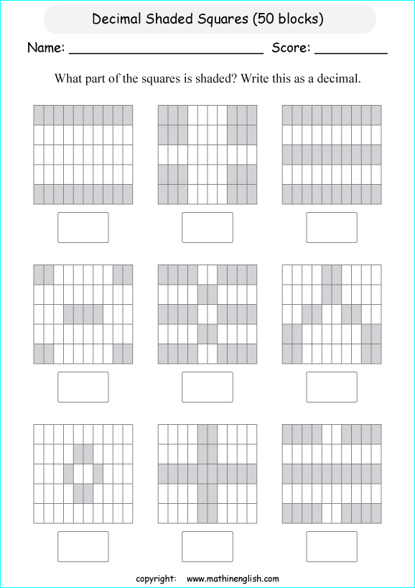
What is the difference between the two squares? (subtract the fractions and then the decimals)
HOMEWORK MONDAY SEPTEMBER 24, 2018
GREEN, RED, BLUE
Simon gave Thor and Carter some decimals to compare. Solve the following problem.
T F
- 1/1000 = 0.001
- 0.8 = 0.08
- 361.81 < 361.18
- 12.12 = 12.120
EXPLAIN your strategy that you used to solve this problem. Draw a place value chart and use math vocabulary: place value, value, hundreds, tens, ones, tenths, hundredths, thousandths, inequality, less than, greater than, equal. The explanation should be at least a paragraph (6-8 sentences or more) with correct grammar.

RED, BLUE: Thor thinks that 1/100 = 0.100 is correct. Is Thor correct? Why or why not (prove by showing the equations.)

BLUE: Create your own chart with two equations correct and two incorrect equations.
HOMEWORK TUESDAY SEPTEMBER 25, 2018
GREEN, RED, BLUE
Simon wants to build steps into the clubhouse. He built a model. Each block is one cubic unit. What’s the volume? Explain if you can or cannot use one volume formula l x w x h for the model unit. Use math vocabulary, formula, volume, equation. (6-8 sentences in a paragraph with correct grammar)


RED, BLUE: Thor said there should be another column of stairs because the stairs are too steep for his fat pug feet. What is the volume now if another row is added to the right side? (Bump up in the height) Draw the picture.

BLUE: Give a volume formula for each column, then add together for a new total volume with the extra column.

HOMEWORK WEDNESDAY SEPTEMBER 26, 2018
GREEN, RED, BLUE (DO ALL PARTS)
Carter is practicing to take a math test to enter college. Provide an answer key to correct his work.
- Write 7 hundredths as a base ten numeral.
____________________________________________________________________
- Write 7 tenths as a base ten numeral.
_____________________________________________________________________
- Compare the two numbers above in an inequality statement using <,>,=
_____________________________________________________________________
Carter said 7 hundredths is greater than 7 tenths. Thor says Carter is incorrect and says Carter is mixing up hundreds with hundredths (the name with the value). Who is correct? Explain using words and numbers or equations. (use a place value chart!) Use a number line to plot points
__________________________________________________________________________________________________________________________________________________________________________________________________________________________________________________________________________________________________________________________________________________________________________________________________________________________________________________________________________________________________________________________________________________________________
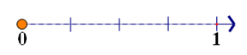
This Photo by Unknown Author is licensed under CC BY
Shade the grid to represent 7 hundredths Shade in the grid to represent 7 tenths
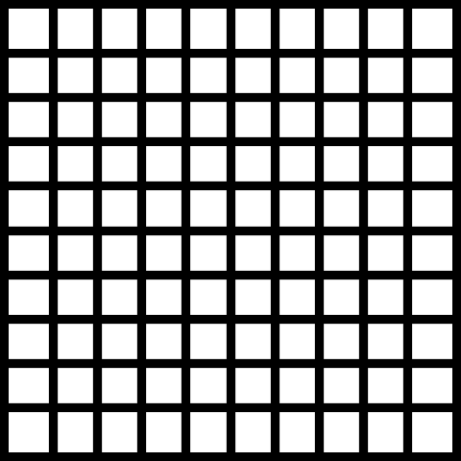
This Photo by Unknown Author is licensed under CC BY-SA
This Photo by Unknown Author is licensed under CC BY-SA
HOMEWORK THURSDAY SEPTEMBER 27, 2018
Rewrite in a column before solving. Show all work.
2,854 + 8,785 + 2,826 | 3,231 + 59 + 880
456 x 31 | 56 x 71
$4,301 - $999 | $52,321 – $6,877
HOMEWORK FRIDAY SEPTEMBER 28, 2018
Re-write in column form before solving and show all work!
4,876 – 1,382 | 8,172 - 963
4,567 + 67 + 912 | 34,762 + 92 + 109
712 x 77 | 34 x 12

